**WEB FRAMEWORKS USING REST API**

**23IT402**

**FORUM**

**IN**

**DISCUSSING FLATFORM**

**ARUN.T**

**IT-A**

**727823TUIT013**

**PROJECT DESCRIPTION:**

The Forum in Discussing Platform project aims to create an online space where users can share ideas, ask questions, and engage in discussions. It features organized topics, user profiles, interactive tools, and moderation to ensure a collaborative and safe environment.**OBJECTIVES:**

* Knowledge Sharing: Create a platform for users to share insights and expertise on various topics.
* Structured Discussions: Organize content into categories and threads for easy navigation and relevance.
* User-Friendly Design: Provide an intuitive interface for seamless usage across devices.
* Collaboration: Enable group discussions and idea-sharing in a collaborative environment.
* Personalization: Allow users to customize profiles and follow topics for a tailored experience.
* Scalability: Build a platform that accommodates growth and increasing activity.
* Accessibility: Ensure inclusivity for users of all skill levels and abilities.
* Lifelong Learning: Support continuous learning and skill development for users.

**SCOPE :**

* User Registration: Users can sign up, log in, and manage profiles.
* Topic Categorization: Discussions are organized into specific categories and subcategories.
* Thread Creation: Users can create, edit, and delete discussion threads.
* Reply System: Users can post replies and comments on threads.
* Search and Filters: Options to search threads and filter by relevance, popularity, or date.
* User Engagement : Features like upvotes, likes, and badges to encourage participation.
* Moderation Tools: Admins and moderators can manage content and user behavior.
* Notifications: Alerts for replies, mentions, and thread updates.
* Mobile-Friendly Design: Accessible on both desktop and mobile devices.
* Security: Secure login, data encryption, and content moderation to ensure safety.

**KEY FUNCTIONALITIES:**

* User Registration and Profiles:     Users can sign up, create personal profiles, and manage their activity.
* Discussion Threads:     Users can post topics and start discussions that others can reply to.
* Search and Filters:     A search bar and filtering options to easily find relevant threads or topics.
* Upvotes and Comments:     Allow users to upvote helpful posts and comment on threads to contribute to discussions.
* Moderation Tools:     Admins can manage inappropriate content by deleting posts and banning users.
* Notifications:     Users receive alerts for replies, mentions, or updates on threads they follow.

CLASS DIAGRAM:

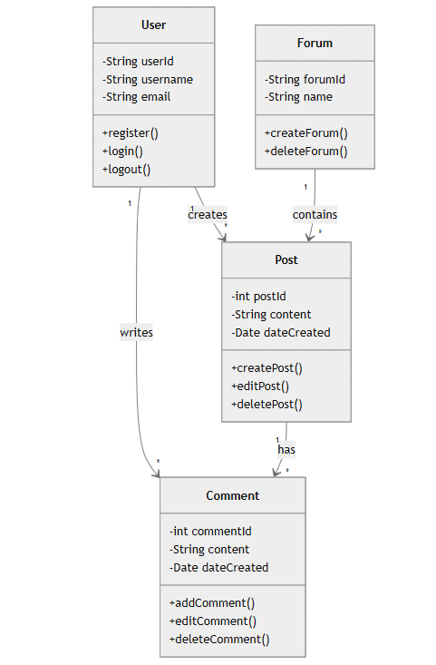

ENTITY RELATIONSHIP DIAGRAM:

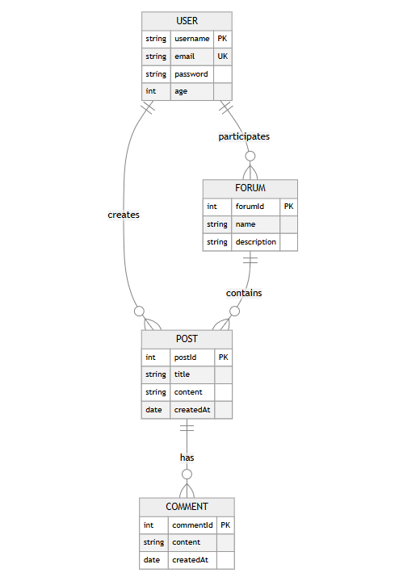

SEQUENCE DIAGRAM:

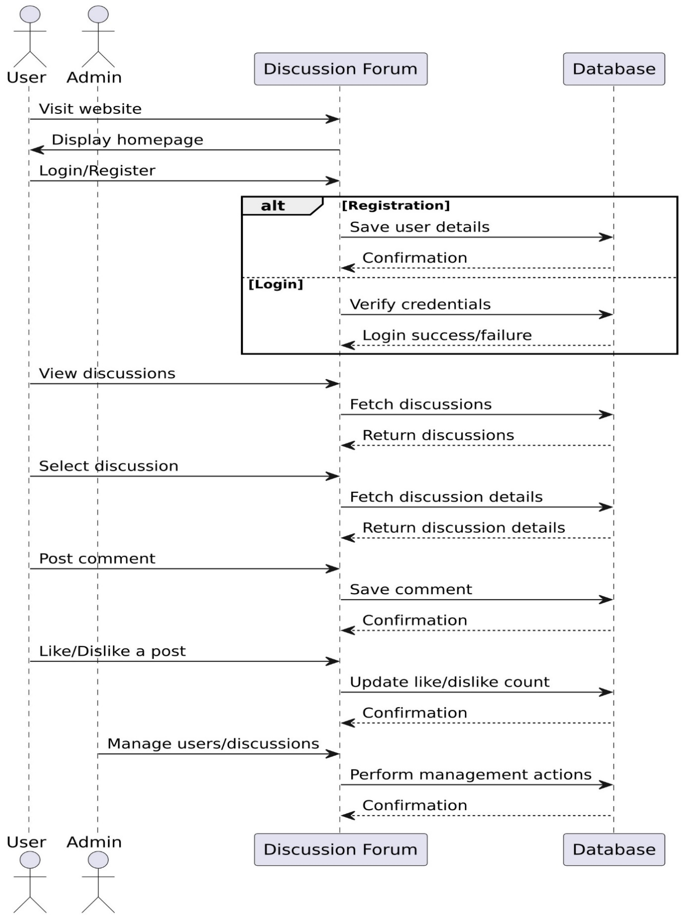

WORK FLOW DIAGRAM:

